Interdisciplinary research competence self-assessment tool

Welcome!

We're excited to have you as part of the Centre for Unusual Collaborations (CUCo, https://unusualcollaborations.com). At CUCo, we believe that the next big innovations for societal impact will be found outside of traditional disciplinary comfort zones. We provide funding and training for scholars and scientists who strive to take an outside-the-box perspective on research, develop collaborations with others from diverse disciplines, and work towards bold ideas that have potential for lasting impact, but may not fit within the boxes of other funding streams.

As part of CUCo’s "Spark" fellowship process, we seek to provide grant applicants and recipients with a way to reflect on their interdisciplinary research competences. Being able to effectively engage in interdisciplinary research requires a diverse set of skills. This self-assessment will provide you with a way to reflect on your competences, determine where your strengths and weaknesses are, and help you to set personal goals about competences that you may want to improve.

If you are applying for the Spark, this self-assessment is for your personal reflection only. It will not affect your current or future applications for CUCo funding.

If you are already a Spark or UCo fellow, we invite you and your fellow team members to make use of this self-assessment both individually and collectively early on in the collective research journey. Fill out the self-assessment on your own and then use it as a point of departure for spurring discussion, collective reflection and action within your team.

Working with this tool individually takes roughly between 60 and 120 minutes. Team reflection takes up to 240 minutes. We advise to fill out the tool individually in a silent place, not necessarily in one go, it may help to take time in between. For the team reflection we advise a structured session with ample time, possibly with external facilitation, in which there is mainly space for listening and any judgment or advice is suspended.

We welcome feedback about how to improve this self-assessment tool. And we’d love to hear from you about the individual and collective insights and actions that using it may enable!

The CUCo team

Basic information
Current Position (choose from: Masters student, PhD candidate, Postdoc, Lecturer, Assistant professor, Associate professor, Full professor, Researcher (other), other (describe))

Field of Study

Reflections
Question 1
Take 10 minutes to explore the below map of academic fields. You can learn more about each field at https://en.wikipedia.org/wiki/List_of_academic_fields.
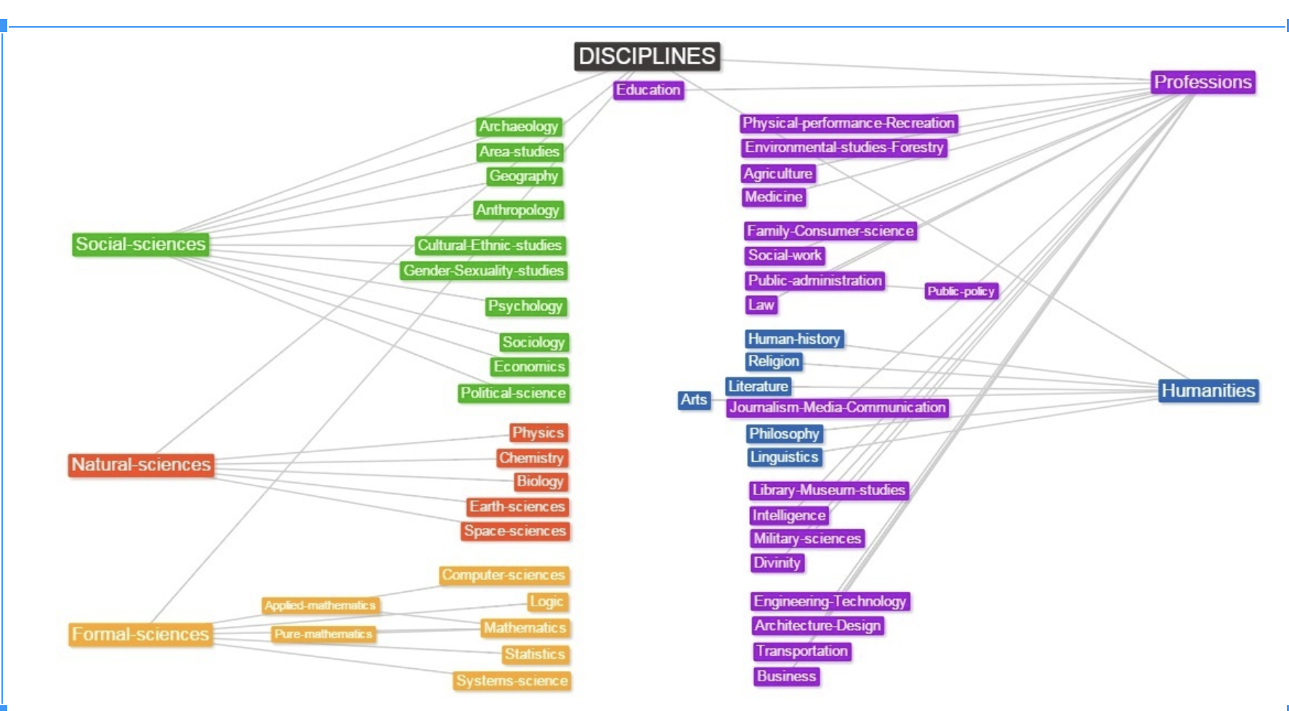

Question 2
[4-5 sentences] Think of a project that you are working on, or an idea in which you are interested. Circle the fields that you think are most likely to have knowledge relevant to the project or idea. What actions have you taken to better understand the research in these fields? Which additional actions could you take to improve how well you understand the research in these fields?

Question 3
[4-6 sentences] Again, look at the above map of academic fields. Now, put a square around fields that could also work on your project or idea, but would approach it from a perspective that is very different from yours. Are there assumptions that people from that field make that are different from the assumptions you make? Can you think of ways that people from that field might complement your knowledge and provide you with a more holistic perspective on your project or idea?

Question 4
[6-8 sentences]. All projects have problems and limitations. Think about a collaborative project that you know well (this could be a project that you were part of, or a project that you know of). Summarize the main problems and limitations that you encountered. List the strategies or approaches that you used to a) identify the above problems and limitations and b) any approaches you used to address or overcome those limitations.

Question 5
[6-8 sentences] Describe one way that the assumptions, theories, or methods in your field have changed over the last 30 years. Were there debates about which assumptions, theories, or methods were better? Describe these debates and the nature of the disagreement.

Question 6
[6 sentences]. Do you know of (or have experience with) a research project where someone has had to integrate conflicting perspectives from different disciplines in order to make progress? Briefly describe the conflicting perspectives and how integration was able to take place. Were there specific approaches, tools or techniques (e.g., group exercises, models, metaphors) that were particularly helpful? If so, describe these. If not, what do you think would have been useful to promote integration and help the project members find common ground?

Question 7
[8 sentences]. Describe an instance when you were part of a collaboration (either scientific or non-scientific) that did not go well and/or was unsuccessful. What made the collaboration unsuccessful and why? Based on these experiences, what did you learn? Did you learn anything specifically about which factors lead to more successful collaborations?

Question 8
[4-6 sentences]. Think about a time when you had a breakdown in communication with another scholar in a) your own field and b) a different field. What went wrong? What lessons did you learn from this? Were there different types of communication issues for a than for b?

Question 9
[8 sentences]. Have you ever worked in an unconventional way that was different from what you were used to? This could include unconventional research approaches, methods, settings, collaborators, and so on. Briefly describe that experience. What did you do to adapt to this situation? Did you learn any lessons about how to successfully (or unsuccessfully) approach unconventional research problems?

Core interdisciplinary competences
Successfully engaging in interdisciplinary research requires a range of skills, many of which are not explicitly taught to scientists during their careers. The above questions were designed to help you to reflect on one of several core competences for interdisciplinary research. Inspired by the Utrecht University general rubric for interdisciplinary education and a scale of interdisciplinary competence developed by Lattuca et al. (2012), there are seven categories of skills that are considered most important for interdisciplinary learning: (a) Disciplinary grounding, (b) Critical thinking competences reflection, (c) Perspective taking (d) Finding common ground and integration, (e) Collaboration, (f) Communication, and (g) Adaptability and creativity.

Each of the letter labels ([a], [b], etc.) for each question corresponded to one of the above competences. In this section, you have the opportunity to learn a bit more about what each competence entails. After doing so, you’ll have a chance to reflect on your answers and think about your unique interdisciplinary skillset. For example, are there competences in which you are particularly skilled? Are competences that you could benefit from further improving? Regardless, this section provides you with a chance to reflect on yourself as an interdisciplinary scholar and make a plan for how to further improve your skills in the future.

Overview and reflection on interdisciplinary competences
- Disciplinary grounding

Disciplinary grounding involves having a basic knowledge and understanding of the involved disciplines as well as ways in which their knowledge is constructed, validated and communicated.
This implies knowing which phenomena are being studied in the disciplines (basic disciplinary concepts, theories, assumptions), understanding the basic assumptions of these disciplines, the epistemology, its methods and ways of validation, and genres of communication (e.g. a research paper, a review, a law, a historical narrative).

- Critical thinking and reflection

Reflection is a purposeful activity in which experiences are analyzed, in order to learn and improve. Evaluating an interdisciplinary project and its value and difficulties makes students aware of the intricacies of interdisciplinary work, and considering how to do it better next time helps consolidate the learning experience.

A broader awareness is reflected in how the proposed solution may impact society (who/what will be affected in terms of e.g. health, politics, economics, social structures, etc.). In addition, the potential limitations of the proposed solution are addressed.

- Perspective taking

Perspective taking involves analyzing the problem from the position of each interested discipline and identifying their commonalities and differences. It also encompasses an attitude of disciplinary humility and open mindedness to and valuing of different perspectives, and the willingness to reflect on of one’s own biases and assumptions.

- Common ground and integration

Common ground is the shared basis between conflicting disciplinary insights or theories. This is a creative process that involves modifying or reinterpreting disciplinary elements that conflict. It also
incorporates the identification of how terms are used differently in different disciplines and defining problems explicitly in neutral terms.

Integrating perspectives involves generating a new understanding that would not have been possible using a single discipline. It includes being able to use integration techniques (e.g. models, metaphors) to find new holistic understanding.

- Collaboration

Interdisciplinary collaboration requires more of researchers’ collaboration skills than disciplinary teamwork does. First, the need to explain and discuss perspectives to each other clearly and build on each other’s ideas is more challenging in interdisciplinary teamwork than when collaborating with scholars from the same discipline, where individuals speak the same language and do not need to explain and discuss everything extensively.

Due to the lack of experience that scholars have in each other’s disciplines where it is not always possible to critically examine the works of others, scholars also need to learn to trust and respect one another. Team and task regulation is needed in all teamwork, although in interdisciplinary collaboration this requires more effort from scholars because they need each other’s contributions and feedback in all parts of the project and are not able to divide tasks as they normally do. Further, the complexity of interdisciplinary projects requires compromising in order to keep the project manageable.

- Communication

Communication in interdisciplinary teamwork includes being open minded and non-judgmental in listening to and trying to understand others’ perspectives. Explaining clearly is important as scholars from other disciplines do not share the same background, as is the awareness of the diversity of disciplinary language, and differences in understandings of concepts and terms.

- Adaptability and creativity

Interdisciplinary work is creative and innovative, with unknown outcomes and a risk of failure. Thus, in interdisciplinary collaboration, scholars have to cope with the fact that nobody has all the answers, and that there may be no one best answer. This requires a tolerance for ambiguity, the courage to venture in unfamiliar space, to grapple with periods of insecurity, and to make mistakes.
Reflection
In the earlier questions, each of the labels corresponded to one of the seven categories of skills that are considered most important for interdisciplinary learning: (a) Disciplinary grounding, (b) Critical thinking and reflection, (c) Recognizing disciplinary perspectives and finding common ground, (d) Collaboration, (e) Communication, and (f) Adaptability and creativity. Each of these questions were meant to help you reflect on one of your competences.

Reflection 1
Look back at your answers to the free-response questions. Pick two questions that were most difficult to answer. What specifically made these questions difficult for you? What does this teach you about the competences you may want to improve?

Reflection 2
Now pick two questions that were the easiest to answer. What specifically made this question easy for you? What does this teach you about which competences you are particularly skilled at?

Reflection 3
Take 10 minutes to skim over your answers in this self-assessment. What general advice would you give to yourself about how to improve your interdisciplinary research competences?

Conclusion
The future of scientific research is one in which scholars increasingly leave their disciplinary comfort zones and engage in challenging outside-the-box collaborations with scholars from diverse backgrounds. Being able to engage in such collaborations requires a range of skills that are often not formally taught to scientists. This self-assessment has provided you with an opportunity to both learn about these skills and reflect on your own skill set. You will be more skilled in some domains than others. You may also be more interested in developing some skills over others, depending on your personal goals and roles in future projects. This is perfectly normal. Just keep in mind that different skills will be useful in different situations, that successful interdisciplinary collaborations benefit from having groups of individuals with complementary skill sets, and that there may be situations in which your collaboration is struggling that can be resolved by having your team improve upon its disciplinary grounding, critical thinking and reflection, ability to take different perspectives, ability to find common ground, collaborative and communicative skills, and its ability to adapt to changing situations by coming up with creative solutions.

